Original: English

Belize’s Electronic Monitoring System (EMS) Domestic Programme Description

Executive Summary

(document submitted by Belize)

In alignment with ICCAT regulatory requirements, the Government of Belize, through the Belize High Seas Fisheries Unit (BHSFU), has committed to full implementation of an Electronic Monitoring System (EMS) across its entire distant water fishing fleet by 2027. The programme is designed to strengthen Monitoring, Control and Surveillance (MCS), improve fisheries data collection for scientific purposes, and enhance compliance verification across the fleet.

Following a successful pilot on five Belize-flagged vessels, Satlink was selected as the preferred EMS service provider. Their system, SeaTube, is a fully integrated electronic monitoring (EM) platform that captures synchronized video, sensor, and GPS data. It has been independently assessed against International Seafood Sustainability Foundation (ISSF) standards and is certified for use in multiple international regulatory frameworks, including National Oceanic and Atmospheric Administration (NOAA)-approved U.S. EMS programs. All data is encrypted using AES-256 and stored on local hard drives aboard each vessel. Data is transmitted ashore via Starlink satellite connectivity and reviewed using Satlink's HORUS platform.

The programme covers both purse seine and longline fishing vessels, with cameras positioned to monitor all critical fishing activities, including catch handling, bycatch and discard events, Fish Aggregating Devices (FAD) deployments, setting, and hauling operations. At programme launch, 4% of recorded footage will be reviewed at random, with the long-term goal of transitioning to a logbook audit model where EM data verifies self-reported catch data. Each vessel will have a tailored Vessel Monitoring Plan (VMP) developed by Satlink, defining camera placement, sensor configuration, and operational procedures specific to the vessel's design and fishing gear. VMPs must be approved by the BHSFU prior to system installation and kept on board at all times during operations.

The programme involves four key parties, each with defined responsibilities. The BHSFU leads overall programme oversight, handles reporting to ICCAT, and ensures regulatory compliance. Shipowners and captains are responsible for the proper day-to-day operation of the onboard EMS, timely reporting of any system incidents, and full cooperation during audits and inspections. The EMS service provider, Satlink, is tasked with developing the VMP for each vessel, carrying out system installation, maintaining data security, and providing ongoing technical support. Finally, the review and analysis company conducts independent analysis of the EM data, upholding the quality, traceability, and integrity of findings in accordance with ICCAT standards.

Recorded data will be retained on board for a minimum of one complete fishing trip and stored in the cloud for one year. Data transmission options include real-time upload, port arrival, on-demand, or event-triggered transfers. All recordings are encrypted, and confidentiality of vessel fishing operations is contractually required. Further details of Belize’s EMS Domestic Programme can be found attached as Annex 1.

Annex 1

Belize

Electronic Monitoring System

Domestic Programme Description

1. Introduction: description of the program and objectives 4
Background 4
Program overview 4
EM program description 4
2. Description of the vessel monitoring plan (vmp) 5
3. Responsibilities of each party 6
4. Protocol for data storage and retrieval 7
Data storage and retention 7
Data retrieval 8
Appendix 1: Vessel Monitoring Plan (VMP) 9
Part A 9
Part B 11
Part C 19
Part D 19
Part E 20

- Introduction: Description of the program and objectives

Background

In alignment with established ICCAT and IATTC regulations on observer coverage and ongoing discussions on Electronic Monitoring System (EMS) standards, Belize has committed to fully implementing EMS across its distant water fishing fleet by 2027. Electronic Monitoring (EM) has been recognized as an effective tool to enhance compliance monitoring and improve the collection of fisheries data for scientific and management purposes. The ICCAT regulation specifies that long line fishing vessels must achieve 10% human and/or EMS observer coverage over the next three consecutive years, while purse-seiners must maintain 100% coverage. Both Regional Fisheries Management Organizations (RFMOs) have established voluntary minimum standards for EMS implementation to ensure that domestic programs meet their intended objectives. Belize has determined that full implementation of EMS across its entire distant water fleet by 2027 will strengthen its Monitoring Control and Surveillance (MCS) strategy while optimizing scientific data collection and quality.

Program Overview

The EM program will collect video footage of all fishing activities. At the outset of this program, 4 percent of this video footage will be reviewed at random to generate EM reports and ensure alignment with the program’s EMS performance standards. Where possible, this data will be compared with logbook data to improve the accuracy of self-reported data, with the long-term goal of transitioning to a logbook audit model where EM is used to verify self-reported data. The Belize High Seas Fisheries Unit (BHSFU) has established performance standards, consistent with RFMO requirements, that EM Service Providers must meet.

As of 14th April 2025, the Government of Belize, through the BHSFU, has announced the implementation of EMS on Belize-flagged fishing vessels as stated in the fishing vessel circular letter no. 067, which can be found in the following hyperlink.

EM Program Description

Following the successful implementation of an EMS pilot on five Belize-flagged vessels, the Government of Belize selected Satlink as its preferred EMS service provider for the implementation of the EMS program. Satlink’s technology is implemented to gather key data in alignment with BHSFU requirements, supporting their oversight and fleet management programs.

SeaTube is Satlink’s Electronic Monitoring system, designed to support fisheries compliance, transparency and reliable data collection. The system has undergone independent external assessment by MRAG against International Seafood Sustainability Foundation (ISSF) requirements (ISSF 2014/08), is aligned with UNE 195007:2021, and complies with EFCA technical guidance (2025 version) and Scottish remote electronic monitoring program standards. It is also certified for Panama’s reefer monitoring program and approved for use in U.S. EMS programs, including National Oceanic and Atmospheric Administration (NOAA) West Coast and New England. These certifications and technical alignments enable SeaTube to operate across multiple regulatory frameworks, supporting authorities, RFMOs and fishing operators in strengthening compliance verification and reporting reliability.

The SeaTube system records video, sensor and global positioning systems (GPS) information through a fully integrated control unit that acts as the core of the EMS system. This unit manages all connected devices, including cameras, sensors, positioning equipment and communication interfaces, ensuring synchronized data capture and stable system performance under marine operating conditions. All data is encrypted at the time of collection and securely stored on local hard drives on board, ensuring its integrity, traceability, and protection against unauthorized access throughout the monitoring process.

The system provides information on the vessel’s position, speed, and course, which facilitates the estimation of fishing effort and total catch, including bycatch and discards. It also allows for the identification of species and, where possible, the estimation of individual fish size, among other objectives as outlined by the EMS program.
- Description of the Vessel Monitoring Plan (VMP)

To ensure effective monitoring of fishing activities on board and the proper adaptation of the EMS to the specific characteristics of each vessel, a Vessel Monitoring Plan (VMP) will be developed for each individual vessel on which the system is installed. Each new installation of the EMS will require the development of a specific VMP, ensuring full compliance with the applicable minimum standards and technical specifications established by ICCAT, particularly those set forth in Annex 4 of ICCAT Recommendation 23-18 (VMP requirements), as well as in the technical annexes related to the minimum standards of the EMS. The VMP will be developed based on a detailed analysis of the vessel’s characteristics (design, work areas, deck layout) and its fishing operations (fishing gear, maneuvers, workflows), defining an optimized system configuration that includes the placement of cameras, sensors, and recording parameters. The template of a VMP is attached in Appendix 1.

Likewise, the VMP will establish the necessary operational procedures to ensure adequate coverage of all relevant activities, the integrity and quality of the collected data, and proper alignment with regulatory requirements. The document will be generated in accordance with the applicable annexes and guidelines and will be submitted to the competent authority of the flag State for review and formal approval prior to the system’s implementation. Once approved, it will be ensured that an up-to-date copy of the VMP is always available on board the vessel during fishing operations.

The EMS system is configured to ensure the monitoring and recording of key fishing activities and associated data, as detailed below depending on the fishing gear:

Table 1 – EM Fields.
Purse Seine fishing vessels
Area Covered | Action covered | Data collected
Work deck (port side) | Brailing | Total catch by set  Species composition
Work deck (port side) | Discards | Total discards by set
Work deck (port side) | Bycatch handling | Bycatch estimation
Work deck (starboard side) | Bycatch handling | Bycatch estimation
Work deck (starboard side) | Bycatch release | Total bycatch by set
In-water purse seine area | Fishing set. Brailing. Net hauling | Total bycatch by set
In-water purse seine area | Bycatch handling of big species (whale sharks, manta rays…) | Total bycatch by set  Bycatch condition  Application of handling and safe-release best practices
In-water purse seine area | Bycatch release of big species (whale sharks, manta rays…) | Total bycatch by set  Bycatch condition  Application of safe-release best practices
Foredeck or amidships | FAD activity (deploying, replacement, reparation…) | Total number of FAD deployments, FAD design and FAD activities by trip
Well deck and conveyor belt | Catch well sorting | Species composition
Well deck and conveyor belt | Bycatch handling | Best practices
Well deck and conveyor belt | Bycatch discarded, released or retained | Total bycatch by set  Species condition  Application of handling and safe-release best practices

Long line fishing vessels
Area Covered | Action covered | Data collected
Setting area (usually stern camera | Setting operation | Setting date time, and position  Use of bycatch mitigation measures or techniques  Total number of hooks set, where applicable  Hook type, where applicable
Hauling area | Hauling operation | Hauling date, time and position
Catch handling area – Working deck | Retained catches, including bycatch | Number of individuals by species  Length and weight, where applicable
Surrounding water area near hauling area | Estimation of discards, including bycatches | Number of discards by species  Condition of discards

- Responsibilities of each Party

In accordance with ICCAT Recommendation 23-18, the implementation and operation of an EMS system require the coordinated involvement of the CPC, the vessel owner/skipper, the EMS system provider, and the entity responsible for data analysis. The responsibilities of each party are as follows:

Belize High Seas Fisheries Unit (BHSFU)

- Ensure that the national EMS program complies with the requirements established by ICCAT, including the existence of a VMP for each vessel and the proper implementation of technical and operational standards.
- Oversee the implementation of the EMS program, ensuring the independence and quality of data analysis, the existence of procedures for system failures, and the monitoring of potential non-compliance.
- Coordinate reporting and communication with ICCAT, including the program description, periodic reports on its implementation, and, where appropriate, the submission of scientific information.

Shipowner and captain

- Ensure the proper operation of the onboard EMS, including not sailing with the system inoperative (unless authorized), refraining from tampering with it, and always keeping the cameras clean and free of obstructions to ensure proper observation, and maintaining the equipment in good condition.
- Report system incidents and facilitate access to the equipment, assisting with maintenance, inspection, and troubleshooting.
- Ensure compliance with operating procedures, including proper visibility of catches, participation in and signing of the VMP, and management of data retrieval and the chain of custody.

EMS service provider

- Develop the Vessel Monitoring Plan (VMP) for each vessel, a critical component of the system, by defining the EMS configuration (cameras, sensors, coverage) based on the vessel’s characteristics and operations, in coordination with the shipowner and the competent authority.
- Install, configure, and ensure the proper functioning of the system, including continuous data recording and the quality and integrity of the recorded information (video, GPS, and sensors).
- Provide documentation, training, and technical support, as well as ensure the security and confidentiality of the information and the operational maintenance of the system.

Review company / EM analysts

- Conduct the analysis of EM data in accordance with the requirements established by the competent authority, ensuring that the review is carried out by independent and authorized entities, in line with ICCAT Recommendation 23-18.
- Ensure the quality, consistency, and traceability of the analysis by using software that allows for the synchronized review of video, images, sensor data, and GPS positioning, as well as the proper management and recording of the analyzed information.
- Ensure that analyst staff meet the requirements established by ICCAT, including sufficient experience in fishing operations and catch handling, the ability to identify species, knowledge of ICCAT conservation and management measures when the program is used for compliance purposes, proficiency in the use of analysis software, and the absence of conflicts of interest or ties to the fishery being analyzed. Furthermore, the confidentiality of the information shall be guaranteed in accordance with applicable requirements.

- Protocol for data storage and retrieval

Data storage and retention

The analysis company will be responsible for receiving, registration, and managing the information to be analyzed, and will notify the shipowner of its receipt and status. To this end, an ERP system will be used to record the voyages to be analyzed, the type of analysis required, and to track the analysis process.

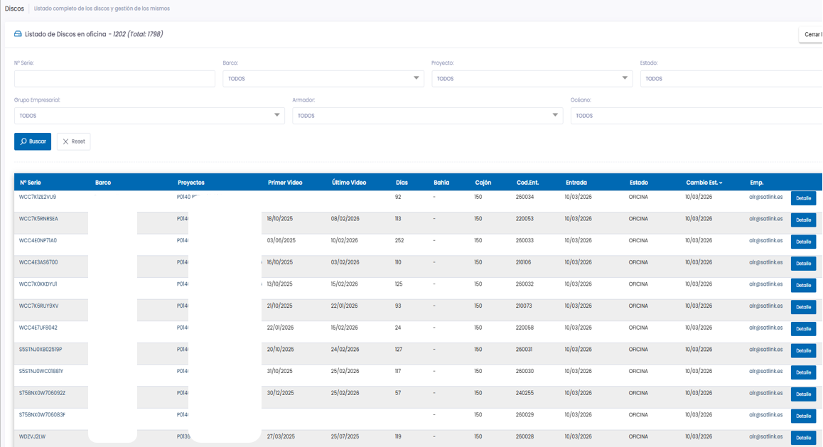
Figure 1. Satlink ERP information management.

The analytics company and the EMS provider shall treat all information relating to the vessel’s fishing operations as confidential and shall agree to this requirement in writing. Once the recordings have been reviewed, they shall be retained for a minimum period of one year.

When the system is used for control and enforcement purposes, the data collected by the EMS shall be retained for as long as necessary until the completion of any associated review or investigation procedures.

Consequently, decisions regarding data storage shall be based on the objectives of the EMS program, including which personnel require access to the records, the frequency of such access, and the purpose thereof.

The EMS system shall have the capacity to store data corresponding to at least one complete fishing trip.

The data generated shall be compatible with the electronic formats required by the ICCAT Scientific Committee (SCRS).

Recordings shall include, at a minimum, the vessel’s name and identification, fishing trip identification, camera number, geolocation with UTC reference, sensor data, and the status of the system and cameras.

Data Retrieval

The information collected by SeaTube needs to be transferred onshore for analysis with the review platform (HORUS). For this project, BHSFU will count with 1-year data retention in the cloud and Satlink will be analyzing 4% of the sets.

The SeaTube is a fully wireless EMS system that, in the scope of this project, transfers data via Starlink, with the option to manually extract encrypted internal hard drives for backup when needed.

The transmission of data from the SeaTube can be configured in several ways: in real time, when the vessel enters port, automatically when it reaches coverage, on demand from shore (e.g., requesting video if sensor data shows something of interest), or automatically triggered by specific events (e.g., when the vessel enters a certain geographical area or when a specific sensor value is reached), or a combination of these options.

Starlink Unit

SeaTube will use satellite connectivity through an IP-67 Starlink antenna (Maritime or Mini model) together with the required components for proper management of the satellite communication service.

The Starlink antennas have been designed for mobility applications and demanding environments. With a wide field of view and enhanced GPS capabilities, it can connect to more satellites, allowing for constant connectivity on the move. The hardware is designed for permanent installation and is more resilient to extreme environments.
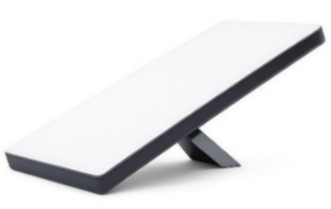

Figure 2. Starlink Mini Model.
To manage the traffic service and add a layer of security and management, Satlink includes a Satlink IMS Server connected to the Starlink antenna system. The Satlink IMS Server allows:

- Cloud-based administration with real-time measurement and analysis.
- Combine and control WAN sources with advanced routing and link bandwidth.
- Protect and ensure network integrity with Deep Packet Inspection (DPI), traffic policies and VPN establishment.

Starlink uses flexible data packages (50GB and 500GB bundles) offering the fastest network speeds (up to 220 Mbps download and 25 Mbps upload) with almost complete global maritime coverage.

The SeaTube system reports the status of the storage units daily to the HORUS platform, enabling efficient planning of data collection. Additionally, this information is available onboard via the Cam Repeater (laptop or tablet), allowing the crew to monitor the system’s status.

All information recorded by the SeaTube solution is stored and protected using AES-256 encryption, ensuring the security, confidentiality, and integrity of the data both during storage and transmission. The system uses unique, randomly generated encryption keys (minimum 20 characters), strengthening protection against unauthorized access and ensuring compliance with applicable security standards.

Appendix 1

Vessel Monitoring Plan (VMP)

Appendix 1 provides a template for a Vessel Monitoring Plan (VMP), which must be adapted to the specific characteristics of each vessel and approved by the BHSFU.

Part A
(To be provided by the ship owner)

- Information provided by the shipowner
Vessel information:
Vessel name
External registry
ICCAT registration number
IMO Code
IRCS
Base port
Length of the vessel
Type of vessel
Major fisheries
Art type
Crew size
May bring an observer (Yes/No)
Contact:
Name of the owner / owner’s representative
Owners or representatives
Address of the owner or representative
Phone number of the owner or representative
Email of the owner or representative
Signing of the document:
Document responsible
Port of installation
Date of installation
Date of last modification
Responsible of the verification
Installer’s signature
Signature of the legal representative

- Description of how the crew handles the fish and any other relevant information

- If available, a copy or image of the ship's general arrangement plan

- General design and layout (not necessarily to scale)

- General comments

Part B
(Responsibility of the competent authority of the flag CPC, and must be validated by the competent
authority of the flag CPC)
- Graphical Documentation

- Vessel images

- Vessel plan and/or general diagram

- Description of fishing activities
Description of the crew’s fish-handling practices and any other relevant information.

- Additional Comments
Special conditions relating to the vessel or its operations.

- System configuration

- Installed equipment for Long Liners
Components | S/N | Model | Units
SeaTube (control box) | - | Nano+ | 1
Camera 1 100º | - | Cam 100º | 1
Camera 2 100º | - | Cam 100º | 1
Camera 3 100º | - | Cam 100º | 1
Camera 4 100º | - | Cam 100º | 1
Camera 5 180º | - | Cam 180º | 1
VMS antenna | - | VMS | 1
UPS | - | UPS | 1
Cam Repeater | - | N/A | 1
Hydraulic sensor | - | ATASI | 1
HDD 1 | - | 2TB SATA II 2.5" | 1
HDD 2 | - | 2TB SATA II 2.5" | 1
HDD 3 | - | 2TB SATA II 2.5" | 1
HDD 4 | - | 2TB SATA II 2.5" | 1
HDD 5 | - | 2TB SATA II 2.5" | 1
HDD 6 | - | 2TB SATA II 2.5" | 1

- Installed equipment for Purse Seiners
Components | S/N | Model | Units
SeaTube (control box) | - | Nano+ | 1
Camera 1 100º | - | Cam 100º | 1
Camera 2 100º | - | Cam 100º | 1
Camera 3 100º | - | Cam 100º | 1
Camera 4 100º | - | Cam 100º | 1
Camera 5 100º | - | Cam 100º | 1
Camera 6 180º | - | Cam 180º | 1
VMS antenna | - | VMS | 1
UPS | - | UPS | 1
Cam repeater | - | N/A | 1
Hydraulic sensor | - | ATASI | 1
HDD 1 | - | 2TB SATA II 2.5" | 1
HDD 2 | - | 2TB SATA II 2.5" | 1
HDD 3 | - | 2TB SATA II 2.5" | 1
HDD 4 | - | 2TB SATA II 2.5" | 1
HDD 5 | - | 2TB SATA II 2.5" | 1
HDD 6 | - | 2TB SATA II 2.5" | 1

- System Operation – Overview

System configuration description:

General description of the onboard system configuration, including cameras, sensors, and recording modes.

Data capture:

List of sensors, if applicable: | Specifications description:

Data transmission:

Description of the available data transmission methods and how the collected information is sent.

- Location of system components

- Location of the system components on board the vessel:
Control box | Control box details:  - Images of the control box location  - Images of the user interface
GPS | GPS details:  - Images of the GPS location
Sensor #X:  (e.g., hydraulic, rotation, proximity, etc.) | X Sensor Detail:  Detection range:  Response time:  Operating temperature:  - Image of the sensor location
Note: Duplicate the row for each of the N sensors installed on the boat.

- Proposed locations and positioning of the cameras:
Camera X – Proposed Location and Positioning
Image showing the location of Camera X | - Image(s) of the location of Camera X
Description of the location of Camera X | Camera type, position, and use  For example: a XXX° camera installed at the stern of the vessel to monitor the casting operation, identify nearby vessels, and verify the crew's safety, health, and working hours
View from Camera X | - Camera view image
Camera  Specifications | FPS  Video Quality  Recording type: 24/7, sensor-triggered (specify which), geofencing, or a combination.  Dynamic masking (Yes/No)  Static masking (Yes/No)  - Image of static masking
Note: Duplicate this table for each of the N cameras installed on the vessel.

- Measurement area
Measurement area X
Date and Time location | Images of the camera X location
Calibration scheme | Including measures and references from the calibration object
Image showing the location of the calibration area | 1) Image showing the location of the X calibration zone  2) Image showing the location of the X camera with the calibration object.
Note: Replicate the table with the N measurement zones defined on the vessel.

- General Arrangement Plan indicating the operational areas of the vessel for Long Liner

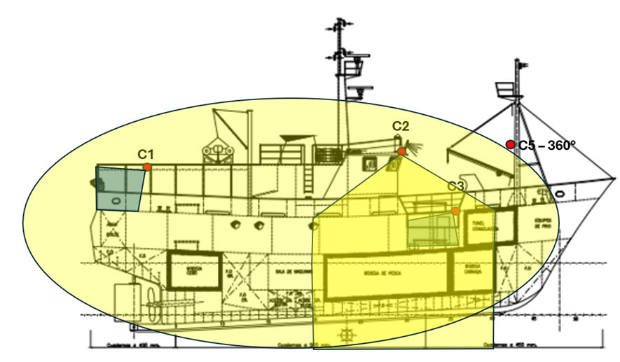
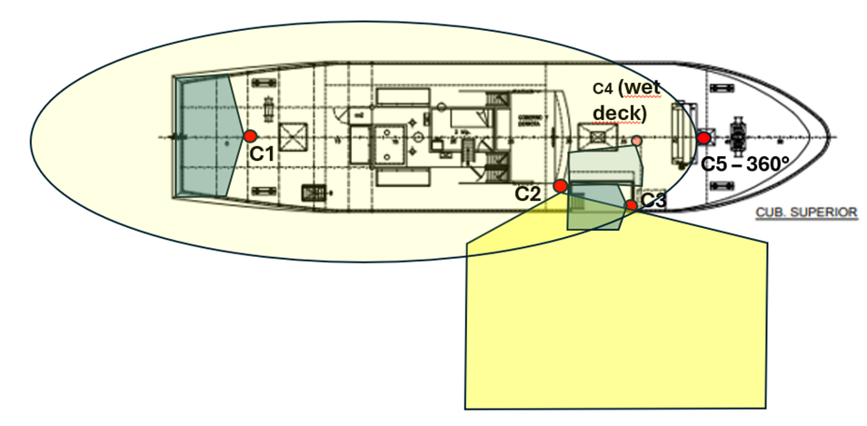

- Description of on-board activities and subject of observation for Long Liner

- Setting
- Hauling, Loading and stowing the catch. Bycatch management
- Loading and stowing the catch
- Stowing the catch
- Vessel's surroundings

- List of designated observation areas for Long Liner
1. Fishing gear deployment
2. Fishing Deck, water surroundings, catch and bycatch fate
3. Catch fate
4. Wet deck, catch fate

- General Arrangement Plan indicating the operational areas of the vessel for Purse Seiner

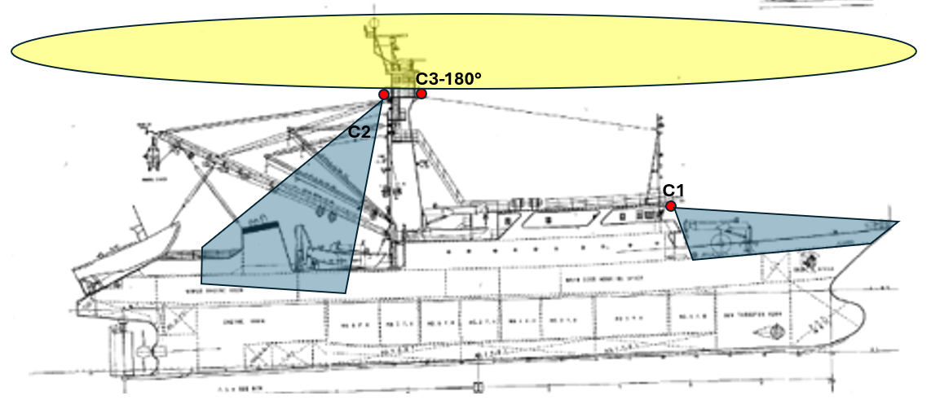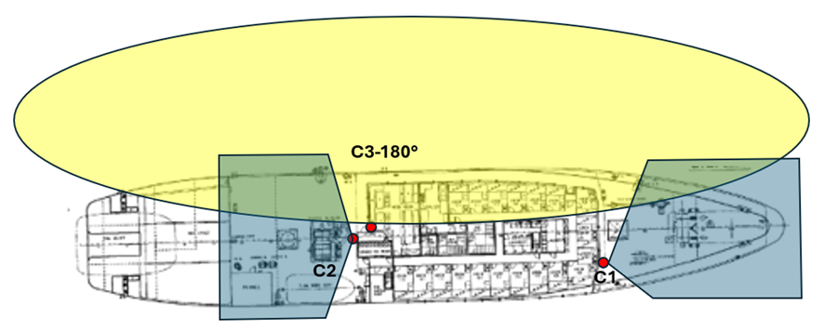

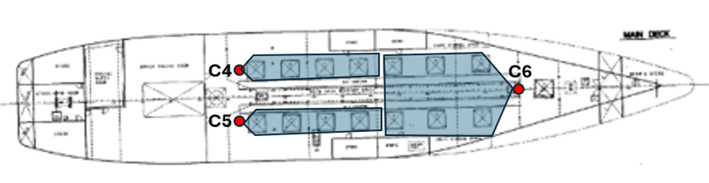

- Description of on board activities and subject of observation for Purse Seiner

- Setting / Hauling
- Loading and stowing the catch. Discarding small pelagic fish from the deck. Bycatch
management
- Loading and stowing the catch
- Deploying and retrieving FADs
- Deploying and retrieving FADs. Discarding bycatch
- Stowing the catch
- Stowing the catch
- Stowing the catch

- List of designated observation areas for Purse Seiner

1. Masthead with a general view of the net in the water and the working deck
2. Masthead with a general view of the net in the water, the working deck, and the fishing deck
3. Console area in front of the gunwales
4. Forecastle for monitoring the deployment/retrieval of FADs from the boat deck
5. Forecastle for monitoring the deployment/retrieval of FADs
6. Fishing deck
7. Fishing deck
8. Fishing deck

Part C
(To be completed by the service provider)

- EM User Guide

a) Description of how to retrieve memory devices
b) Description of how to power the system (To be completed by the service provider)
c) Description of how to perform a functional test

- Vessel-specific handling protocols

Description of any special protocols that may apply to the vessel mentioned in the VMP.

- Description and diagrams of checkpoints with specific procedures performed. For each area description, there must be a protocol on how to ensure that the catch remains in view of the Camera.

Part D
(To be completed by the service provider)

Contact information for EMS service providers:
Name and Surname | Phone | Email | Business Adress

Part E
(This form must be completed by the shipowner and the service provider)

This section should certify that the shipowner/ship operator has received training on the operation of the EMS installed on the vessel, and that the operator agrees to comply with the VMP.

First and last name of the vessel operator:__________________________________________
Signature of the shipowner/operator: _____________________--________________________
Date and time: ________________________________________________________________
First and last name of the EMS service provider: _____________________________________
Signature of the EMS service provider: _____________________________________________
Date and time: ________________________________________________________________



Aura Building, 2nd Floor
4.5 Miles Philip Goldson Highway
Belize City, Belize
T. +501-223-4918
+501-223-5026
info@bhsfu.gov.bz


INNOVACIÓN I TECNOLOGÍA I SOSTENIBILIDAD

Carretera de Fuencarral
Arbea Campus Empresarial - Building 5, Ground Floor
28108 Alcobendas – Madrid, Spain
T. +34 91 327 21 31
F. +34 91 327 21 69
emsales@satlink.es

